**STEP 1**

Create user in SQLPLUSE and access admin rights to normal user.

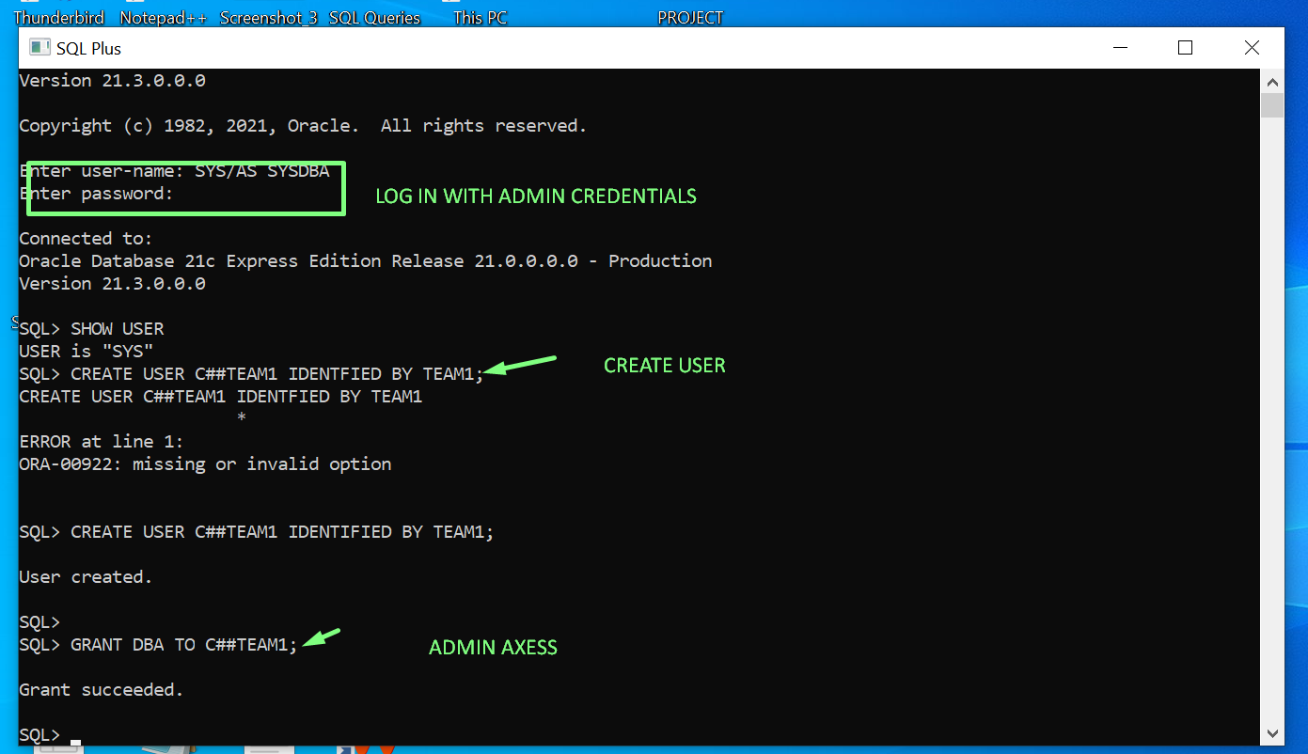

Log in with new user in SQL developer

**TASK 1**

**TABLE 1**

1.CREATE TABLE ARTIST (

ARTISTID NUMBER(30),

NAME VARCHAR2 (255),

CONSTRAINT PK_ARTISTID PRIMARY KEY(ARTISTID));

**TABLE 2**

CREATE TABLE ALBUM (

ALBUMID NUMBER(30),

TITLE VARCHAR2 (255),

ARTISTID NUMBER (30),

CONSTRAINT PK_ALBUMID PRIMARY KEY(ALBUMID),CONSTRAINT FK_ARTISTID FOREIGN KEY (ARTISTID)REFERENCES ARTIST(ARTISTID));

**TABLE 3**

CREATE TABLE GENRE (

GENREID NUMBER(30),

NAME VARCHAR2 (255),

CONSTRAINT PK_GENREID PRIMARY KEY(GENREID));

**TABLE 4**

CREATE TABLE MEDIATYPE (

MediaTepeId NUMBER(30),

NAME VARCHAR2 (255),

CONSTRAINT PK_MediaTepeId PRIMARY KEY(MediaTepeId));

**TABLE 5**

CREATE TABLE Playlist (

PlaylistId NUMBER(30),

NAME VARCHAR2 (255),

CONSTRAINT PK_PlaylistId PRIMARY KEY(PlaylistId));

**TABLE 6**

CREATE TABLE PLAYLIST_TRACK (

PLAYLISTID NUMBER(38),

TRACKID NUMBER (38),CONSTRAINT FK_PLAYLISTID FOREIGN KEY(PLAYLISTID) REFERENCES PLAYLIST(PLAYLIST),

CONSTRAINT FK_PLAYLISTID FOREIGN KEY(PLAYLISTID) REFERENCES PLAYLIST(PLAYLIST));

**TABLE 7**

CREATE TABLE TRACK (

TRACKID NUMBER(38),

NAME VARCHAR(255),

ALBUMID NUMBER(38),

MEDIATYPEID NUMBER (38),

GENREID NUMBER (38),

COMPOSER VARCHAR (255),

MILLISECOUND NUMBER (38),

BYTES NUMBER (38),

UNITPRICE NUMBER (3,2),CONSTRAINT PK_TR_TRACKID PRIMARY KEY (TRACKID),

CONSTRAINT FK_TR_ALBUMID FOREIGN KEY(ALBUMID) REFERENCES ALBUM(ALBUMID),

CONSTRAINT FK_TR_MEDIATYPEID FOREIGN KEY(MEDIATYPEID) REFERENCES MEDIATYPE(MediaTepeId),

CONSTRAINT FK_TR_GERNEID FOREIGN KEY(GENREID) REFERENCES GENRE(GENREID));

Tables created and maintain relation b/w tables by using primary key and foreign key.

**STEP 2**

LOAD DATA BY USING DIFFERENT METHODS

Type 1: - insert method

This are two types 1.Direct method

2.Reference method.

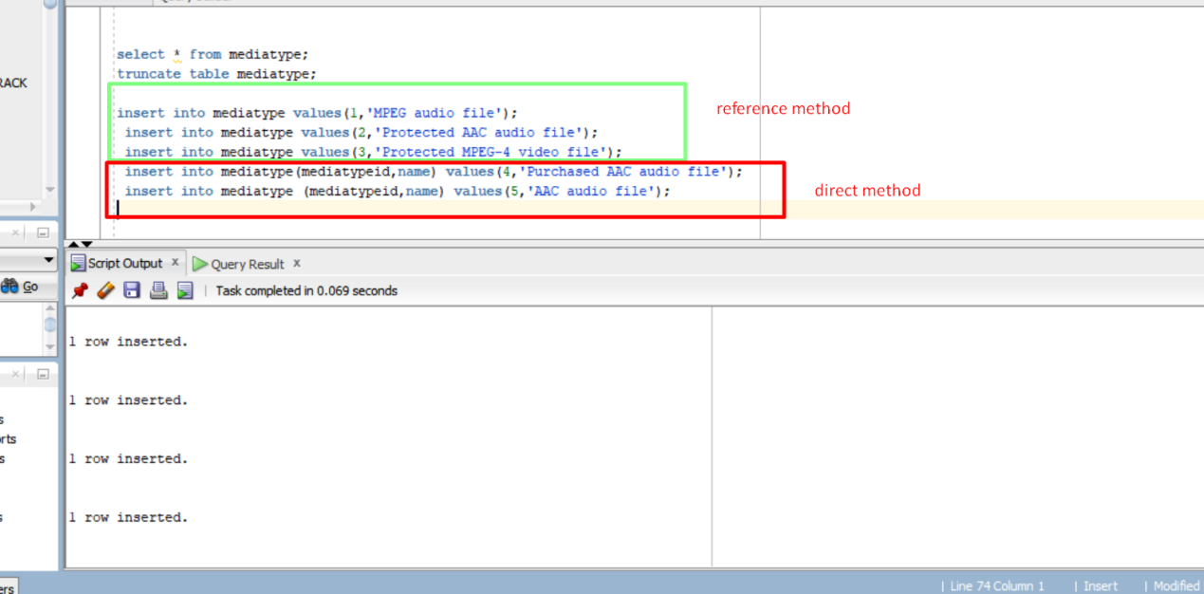

Type 2

SQL developer method

Step to import data from source data

Click on schema ---> click on table name --->